(a) i. State whether or not the following statement is true or false: “all individuals
presented with an identical stimulus will process it in the same way”. (1 mark)
_____________________________________________________________________
Question 5 (12 marks)

(a) Name two recreational drugs (2 marks)

One: _________________________________________________________

Two: _________________________________________________________
Question 6 (18 marks)

(a) i. State whether or not the following statement is true or false: “all individuals
presented with an identical stimulus will process it in the same way”. (1 mark)
_____________________________________________________________________
(b) i. The Müller-Lyer illusion (shown below) is considered to be a visual illusion.
Define the term ‘visual illusion’. (1 mark)
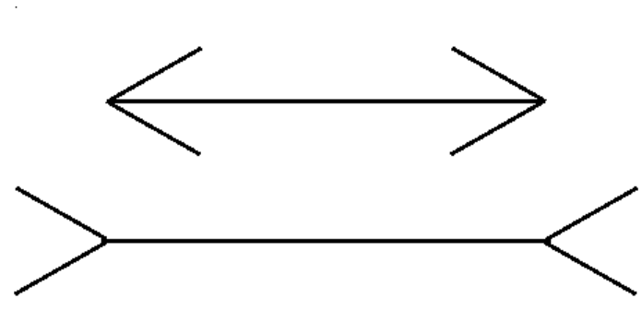

ii. Outline one theory of that can be used to explain visual illusions
(2 marks)

____________________________________________________________________________________________________________________________________________________________
____________________________________________________________________________________________________________________________________________________________
______________________________________________________________________________

iii. Name the feature of the stimulus being consistently misjudged in the Müller-
Lyer illusion. (1 mark)
_____________________________________________________________________

(d) Identify the test that measures the electrical activity of the skin and outline how it works (3 marks)
____________________________________________________________________________________________________________________________________________________________
____________________________________________________________________________________________________________________________________________________________
______________________________________________________________________________
(e) Leonard High School does not allow students to listen to music while doing their classwork due to a large body of published research into the effectiveness of multi-tasking. Using psychological terminology, explain why the school does not allow students to listen to music while they are doing class work. (3 marks)

____________________________________________________________________________________________________________________________________________________________
____________________________________________________________________________________________________________________________________________________________
____________________________________________________________________________________________________________________________________________________________
(b) List three elements of body language. (3 marks)

• ___________________________________________________________________________

• ___________________________________________________________________________

• ___________________________________________________________________________

(a) Define the term ‘intelligence test’. (1 mark)

____________________________________________________________________________________________________________________________________________________________
______________________________________________________________________________
ii. Using the Multiple Intelligence theory what one intelligence is Mohammad struggling with. Explain your answer using examples from the scenario (2 marks)

______________________________________________________________________________

______________________________________________________________________________
______________________________________________________________________________

(g) Modern tests use deviation IQs. The formula is IQ = MA/CA x 100

i. Identify what the abbreviation ‘MA’ stands for. (1 mark)

_____________________________________________________________________

ii. Identify what the abbreviation ‘CA’ stands for. (1 mark)

_____________________________________________________________________
Question 8 (continued)

(h) Outline two advantages of group intelligence testing. (2 marks)

_____________________________________________________________________
_____________________________________________________________________
_____________________________________________________________________
_____________________________________________________________________
_____________________________________________________________________

(a) After two days of torrential rain, a state of emergency was declared in Vienna after
flooding occurred. During such disasters, examples of both anti-social and pro-
social behaviour occurs.

i. Referring specifically to floods, describe one examples of anti-social behaviour
that may be evident. (1 marks)
_____________________________________________________________________

ii. Referring specifically to floods, describe one examples of pro-social behaviour
that may be evident. (1 marks)
_________________________________________________________________
(b) A high school teacher was noticing an increase in anti-social behaviour amongst middle school students. Outline one way that this teacher could promote pro-social behaviour. (2 marks)
____________________________________________________________________________________________________________________________________________________________
______________________________________________________________________________

iii. How many participants were in his study (2 mark)

_________________________________________________________________

Question Five – Cognition (18 marks)

- With reference to the brain wave diagram complete the table below. (8 marks)
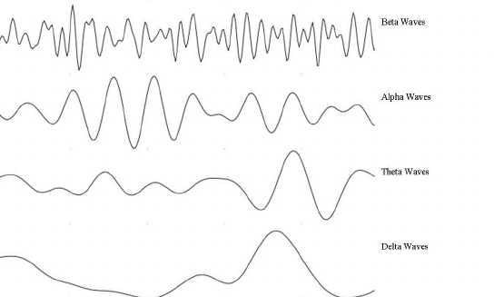

- Frequency (1) for State of Consciousness
Brain Wave | Name | Frequency (per second) and amplitude of waves | State of consciousness of the person
1 | Beta | ~ 12 – 27 Hz | Awake, normal waking consciousness, Alert
2 | Alpha | ~8 – 12 Hz | Relaxed, Calm, Lucid, Not thinking
3 | Theta | ~ 3 – 8 Hz | Tired, Relaxed, Daydreaming
4 | Delta | ~0.2 – 3 Hz | Deep sleep, REM sleep

Brain Wave | Name | Frequency (per second) and amplitude of waves | State of consciousness of the person
1 | Beta | - 15-40 cycles per second  - Smallest amplitude (small peaks and troughs) | Alert
2 | Alpha | - 9-14 cycles per second  - Higher amplitude than Beta | Relaxed/reflecting
3 | Theta | - 5-8 cycles per second  - Higher amplitude than Beta, smaller than Alpha | Drowsy/ideating
4 | Delta | - 1.5-4 cycles per second  - Higher peaks and troughs than all previous brain waves | Asleep (REM)
5 | Delta | - 2-3 cycles per second  - Highest amplitude of all brain waves | Asleep (non-REM)

- Steven is preparing to complete a timed IQ test. He is feeling alert and slightly anxious before the start of the test, however as soon as the test starts he feels calm and confident. Steven concentrates solidly and without a break for the entire hour-duration of the test. Immediately after completing the IQ test Steven, feeling slightly tired and fatigued at his efforts, sits and daydreams for a short period.

Explain the changes in each of the measures of states of consciousness below that Steven would have experienced from before the IQ test began, through to his daydreaming at the end.
(6 marks)
At least (2) from each section talked about
- Body temperature:
Increases before the test / when anxious (1)
Test starts back to normal range ~ 38 degrees (1)
After test temperature drops slightly (1)

- Brain waves:
Beta waves – alert / stressed
Alpha – Calm / Relaxed
Theta – Tired / Daydreaming

- Galvanic skin response:
Conductivity of the skin increases before the test / more sweat when anxious (1)
Test starts back to average conductivity as he calms (1)
After skin is at its lowest level of conductivity (1)

- Heart rate:
Increases before the test / when anxious (1)
Test starts back to normal range ~ 38 degrees (1)
After Heart rate back to normal / slows slightly (1)

- Identify the correct Intelligence theorist or researcher (3 marks)

- Galton

Proposed that intelligence is a general overarching ability to that shows itself in different ways depending on the environment.

- Binet

Theorised that intelligence is inherited and the strongest predictor of success in life, he then popularised the Stanford-Binet scale of intelligence in America.

- Gardner

Theorised that intelligence is not one ability but split into nine separate intelligences, which we each have in unique combinations.

a) State two reasons why people take recreational drugs. (2 marks)

Description (any two of the following) | Marks
• To get a ‘high’.  • To alter their consciousness.  • To have fun.  • To reduce psychological distress.  • To help enhance identity.  • To feel accepted.  • To reduce a sense of alienation.  • To relax.  • As a mechanism for coping with pressure.  Any relevant reason accepted for one mark | 1-2
Total | 2

a) i. State whether or not the following statement is true or false: “all individuals presented with
an identical stimulus will process it in the same way”.
(1 mark)

Description | Marks
False | 1
Total | 1

ii. List two features of a stimulus that are consistently misjudged in visual illusions. (2 marks)

Description (any two of the following) | Marks
• Position.  • Curvature.  • Motion.  • Size.  • Direction.  • Length.  • Colour. | 1-2
Total | 2

ii. List two features of a stimulus that are consistently misjudged in visual illusions. (2 marks)

Description (any two of the following) | Marks
• Position.  • Curvature.  • Motion.  • Size.  • Direction.  • Length.  • Colour. | 1-2
Total | 2

ii. List two features of a stimulus that are consistently misjudged in visual illusions. (2 marks)

Description (any two of the following) | Marks
• Position.  • Curvature.  • Motion.  • Size.  • Direction.  • Length.  • Colour. | 1-2
Total | 2

e) Leonard High School does not allow students to listen to music while doing their classwork due
to a large body of published research into the effectiveness of multi-tasking. Using psychological
terminology, explain why the school does not allow students to listen to music while they are
doing class work. (3 marks)

Description | Marks
Listening to music at the same time as doing classwork involves divided attention.  This means that only part attention will be given to both tasks  rather than full attention given to the school work. | 1  1  1
Total | 3

b) List three elements of body language. (3 marks)

Description (any three of the following) | Marks
• Body posture.  • Facial expressions.  • Hand gestures.  • Eye movement.  • Touch.  • Use of space.  Any relevant element accepted for one mark | 1-3
Total | 3

d) Contrast between effective listening and active listening. (2 marks)

Description | Marks
Effective listening occurs when the listener tries to understand what the speaker is saying as clearly as possible whereas;  active listening involves the listener trying to empathise with the speaker/understand what the speaker is feeling. | 1  1
Total | 2

a) Define the term ‘intelligence test’. (1 mark)

Description | Marks
A series of tasks created to assess the ability to learn, adapt to new situations and think abstractly.  Any relevant definition accepted for one mark | 1
Total | 1

b) The test created by Simon and Binet consisted of a number of items which were scored on a
pass or fail basis. Identify the number of items included in the scale. (1 mark)

Description | Marks
30 | 1
Total | 1

c) According to Simon and Binet’s intelligence test, if a child who sat the test was able to answer
the majority of questions that other children of the same age could answer, what could be said of
the intelligence of the child? (1 mark)

Description | Marks
The child has normal intelligence | 1
Total | 1

e) Outline two changes that Terman, an American psychologist at Stanford University, made to
Simon and Binet’s original intelligence test. (2 marks)

Description | Marks
• Translated the test from French into English.  • Revised the test so it was suitable for ages 2 to 85+ rather than just for children.  Any relevant change accepted for one mark | 1  1
Total | 2

f) Both the Stanford-Binet Intelligence Scale (created by Simon, Binet then revised by Terman)
and Wechsler’s Intelligence scales separate subtests or factors into two main categories. These
two categories allow for those with limitations in reading to not be disadvantaged. Name these
two categories. (2 marks)

Description | Marks
Verbal/verbal-based questions | 1
Non-verbal/non-verbal based questions | 1
Total | 2

i. Identify what the abbreviation ‘IQ’ stands for. (1 mark)

Description | Marks
Intelligence quotient | 1
Total | 1

ii. Identify what the abbreviation ‘MA’ stands for. (1 mark)

Description | Marks
Mental age | 1
Total | 1

iii. Identify what the abbreviation ‘CA’ stands for. (1 mark)

Description | Marks
Chronological age | 1
Total | 1

h) There are advantages and disadvantages of both group and individual intelligence testing.

i. Explain how the examiner needing to have rapport or a positive relationship with the test taker
can be an advantage as well as a disadvantage in individual intelligence testing. (2 marks)

Description | Marks
Advantage: building a positive relationship allows the test-taker to feel at ease.  Disadvantage: building a positive relationship takes time to establish. | 1  1
Total | 2

ii. Outline two advantages of group intelligence testing. (2 marks)

Description | Marks
• Test conditions are the same for all test-takers in the group.  • It is less expensive to run compared to individual intelligence testing.  • Test-takers can complete the test without interacting with the examiner.  • The instructions are simpler to follow than instructions for individual intelligence  testing.  Any relevant advantage accepted for one mark | 1-2
Total | 2

After two days of torrential rain, a state of emergency was declared in Vienna after flooding
occurred. During such disasters, examples of both anti-social and pro-social behaviour occur.

i. Referring specifically to floods, describe two examples of anti-social behaviour that may
be evident. (2 marks)
Description (any two of the following) | Marks
• People looting shops and businesses.  • People stealing donations collected for victims of the flood.  • People claiming benefits/insurance payouts that they are not entitled to.  Any relevant example accepted for one mark | 1-2
Total | 2

ii. Referring specifically to floods, describe two examples of pro-social behaviour that may
occur. (2 marks)
Description (any two of the following) | Marks
• People donating to charities/helping to fundraise for victims of the floods.  • People volunteering for organisations that help victims of the floods.  • People acting as volunteers for disaster relief.  Any relevant example accepted for one mark | 1-2
Total | 2

e) For each of the statements below, decide whether it is describing a dyad, clique, crowd or none
of the above.

i. Andrea and Michael from question (9d). (1 mark)

Description | Marks
Dyad | 1
Total | 1

ii. All the people waiting at the Perth train station for the 8am train. (1 mark)

Description | Marks
None of the above | 1
Total | 1

iii. Year 12 students attending the ball after party. (1 mark)

Description | Marks
Crowd | 1
Total | 1

iv. Four primary school students who sit together every recess and lunch time. (1 mark)

Description | Marks
Clique | 1
Total | 1

